**Orders API Code Challenge**

**Technologies used:** Dot Net Core API 8.0, Postgres SQL, Swager

**API’s:**

Below is the API used

1. GetOrder
2. GetOrderID
3. CreateOrder
4. CreateOrderItems
5. UpdateOrderDetails
6. DeleteOrderItem

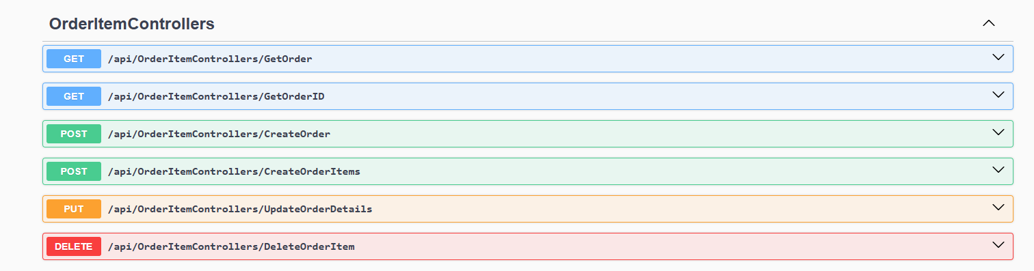

**Postgres SQL:**

Below are the tables used

**Table 1:** orders – To store order Id (Auto increment) and customer name

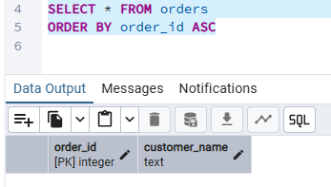

**Table 2:** order_items – To store Order id, item_id (auto increment), product name, quantity and order state

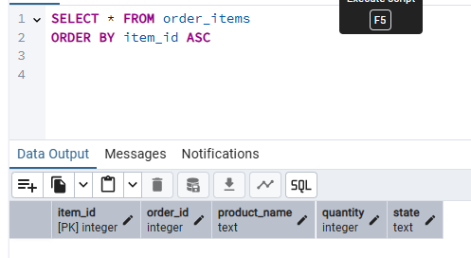

**API- HTTPPost Definition for Order :**

CreateOrder – To create customer name and auto increment of order id

**Required Field:**

**Auto Increment – Order_id**

**Request body – Customer Name**

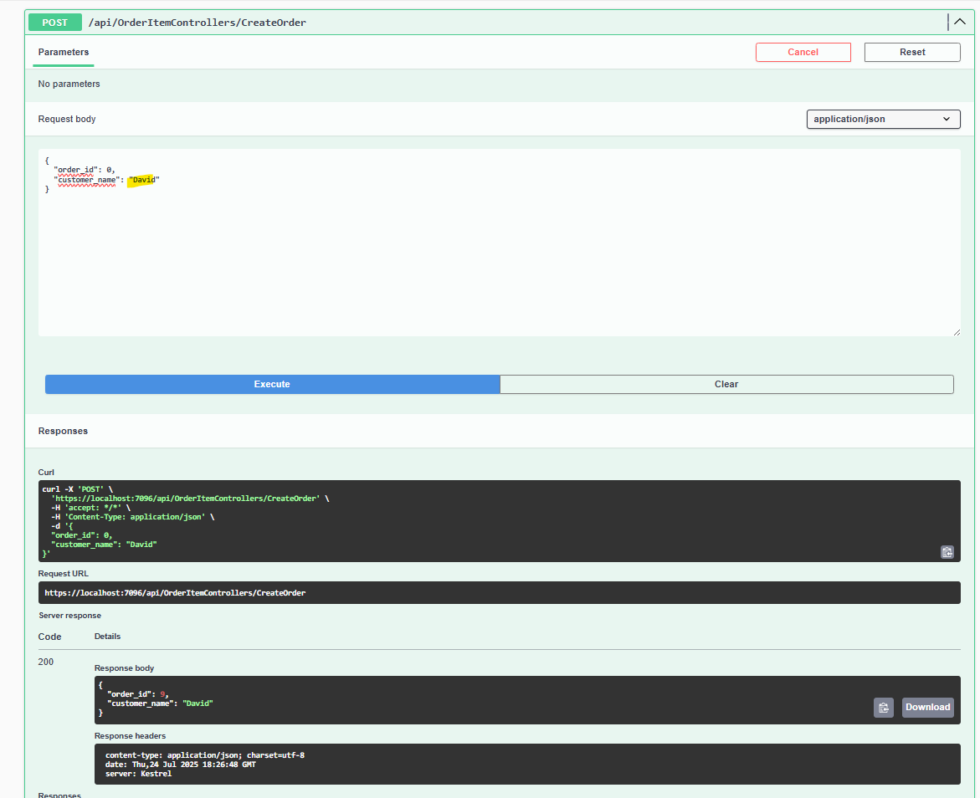

**API- HTTPPost Definition for order_items :**

CreateOrderItem – To create order item under the order. Multiple items can be created for the same order id.

**Required Field:**

**Auto Increment – Item_id**

**Request body – Order id, Product Name, Quantity and Status (should be Draft)**

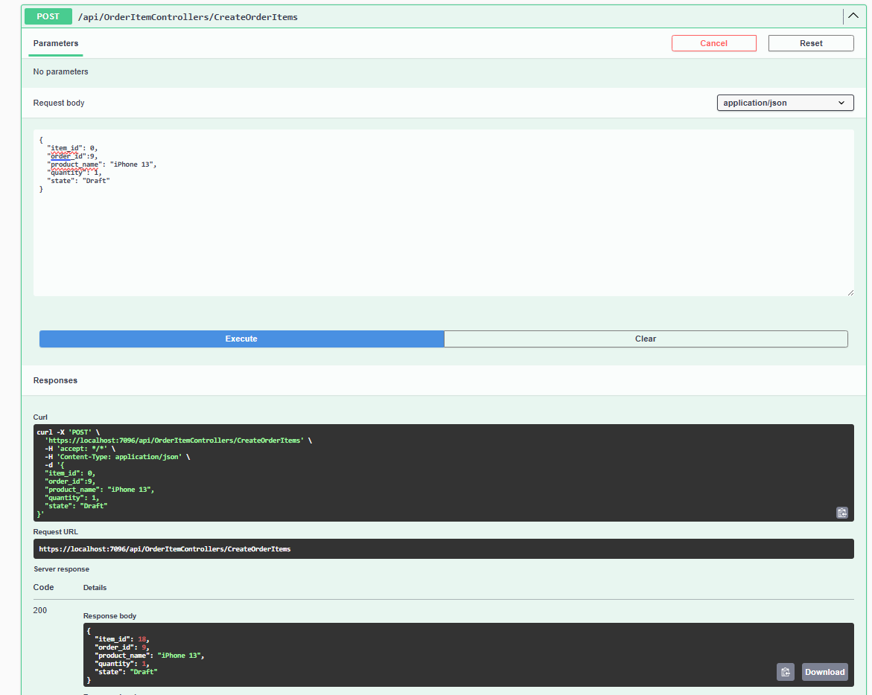

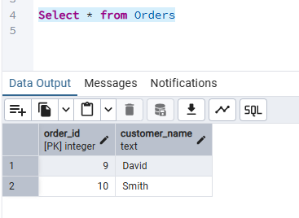

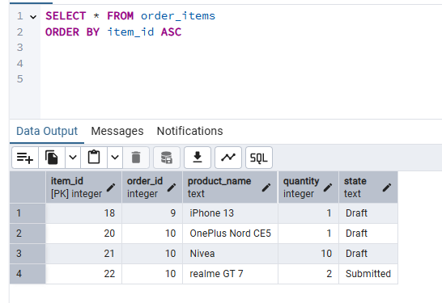

**API- HTTPGet Definition for order_items :**

GetOrderID - To retrieve the order items associated to the order item

**Required Field:**

Order_id in the input box

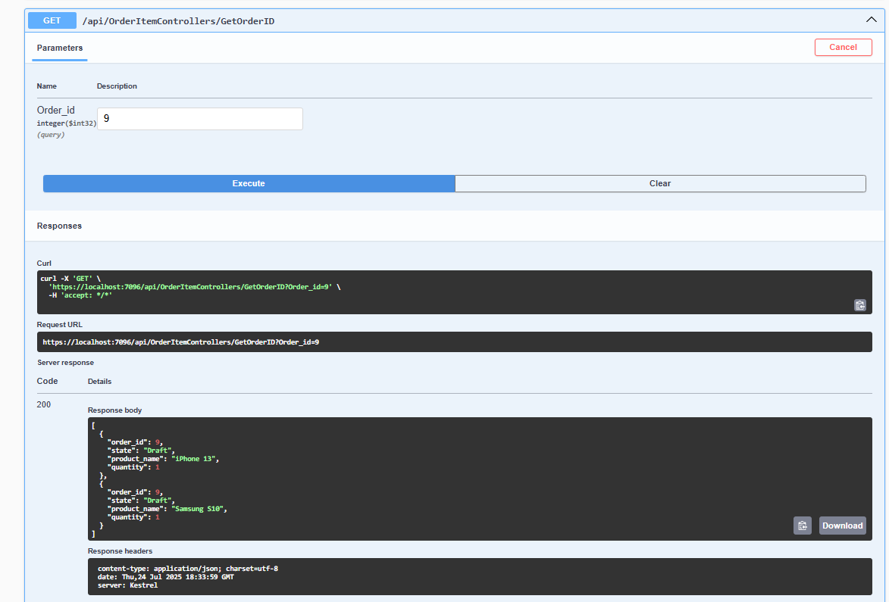

**API- HTTPGet Definition for order_items :**

GetOrder – To retrieve all data from order items

**Required Field: There is no required field, just click on execute**

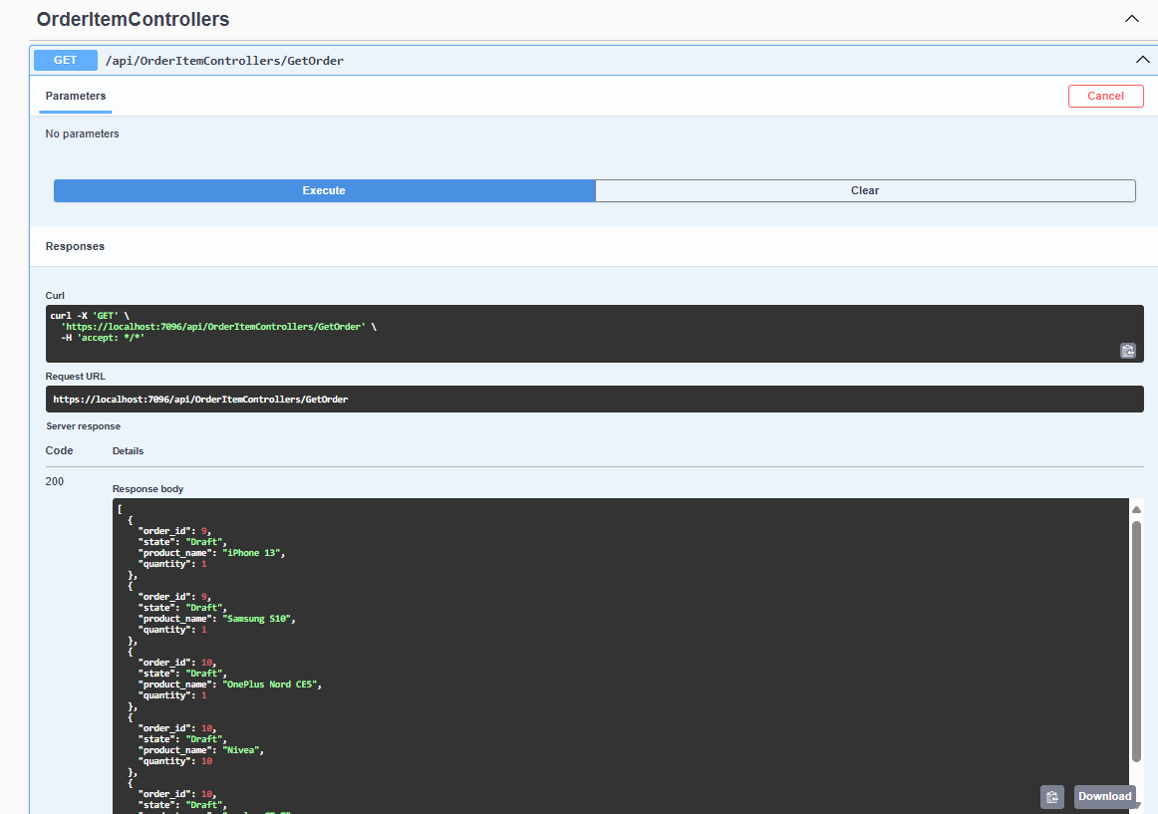

**API- HTTPPut Definition for order_items :**

UpdateOrderDetails – To change the status and order details

**Required Field:**

Item_id as highlighted in the input box

Request body – Order Item id, Product Name, Quantity and Status

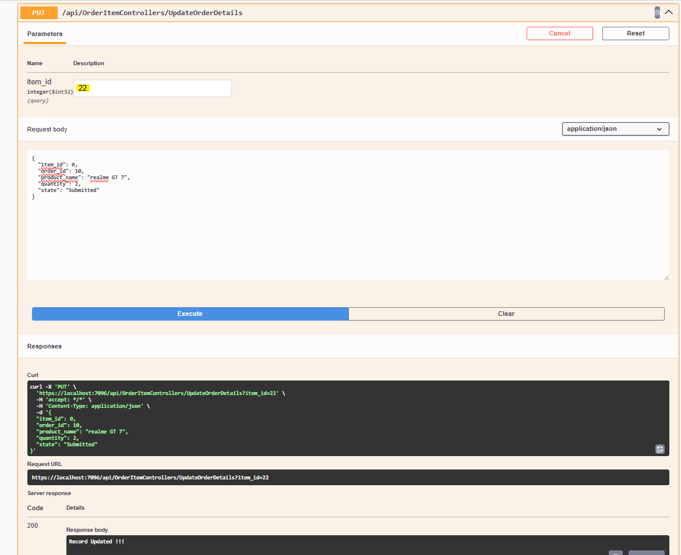

**API- HTTPDelete Definition for order_items :**

DeleteOrder – To delete the given order item id

**Required Field:**

Order Item_id as highlighted in the input box

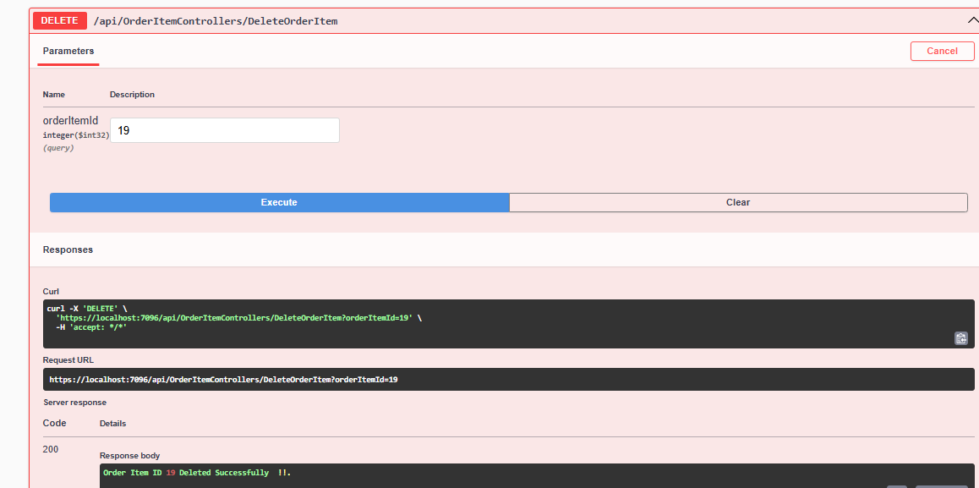

**Note:** I have implemented the given business logic, validation, error handling, storing the data in Postgres SQL and testing.